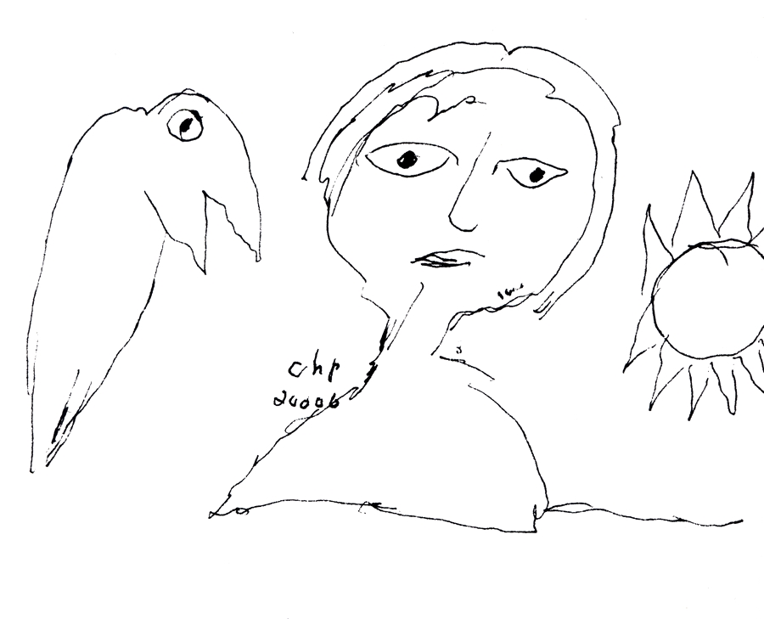DOCUMENT 2Carl-Henning Pedersen, Reality and dream ( dessin, 2006), in Carl-Henning Pedersen, ed. Guy Pieters ;

